**Institute of Information Technology (IIT)**

Jahangirnagar University



**EDGE- B11 Cyber Security.**

**Project No 3:**

Disk Forensics with Autopsy and FTK Imager

**Submitted By**

Name: Shariful Islam

ID No: 2111252

Batch No: B-11

**Submitted To**

  Moinoddeen Quader Al Arabi

   Ethical Hacker, Forensic Investigator, and VAPT Expert Cyber Security Consultant in Dhaka Division, Bangladesh

**Disk Forensics with Autopsy**

Create New Case:

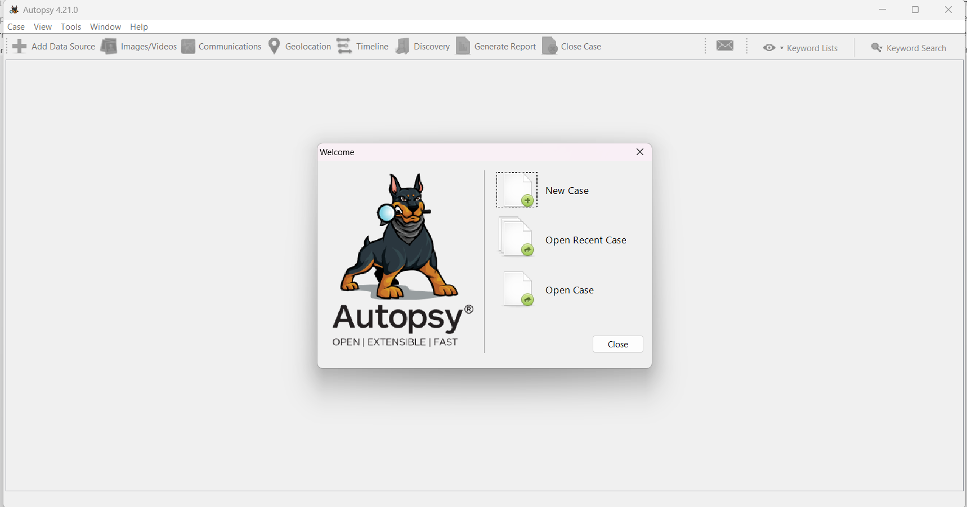

Set a Case Name and Base directory:

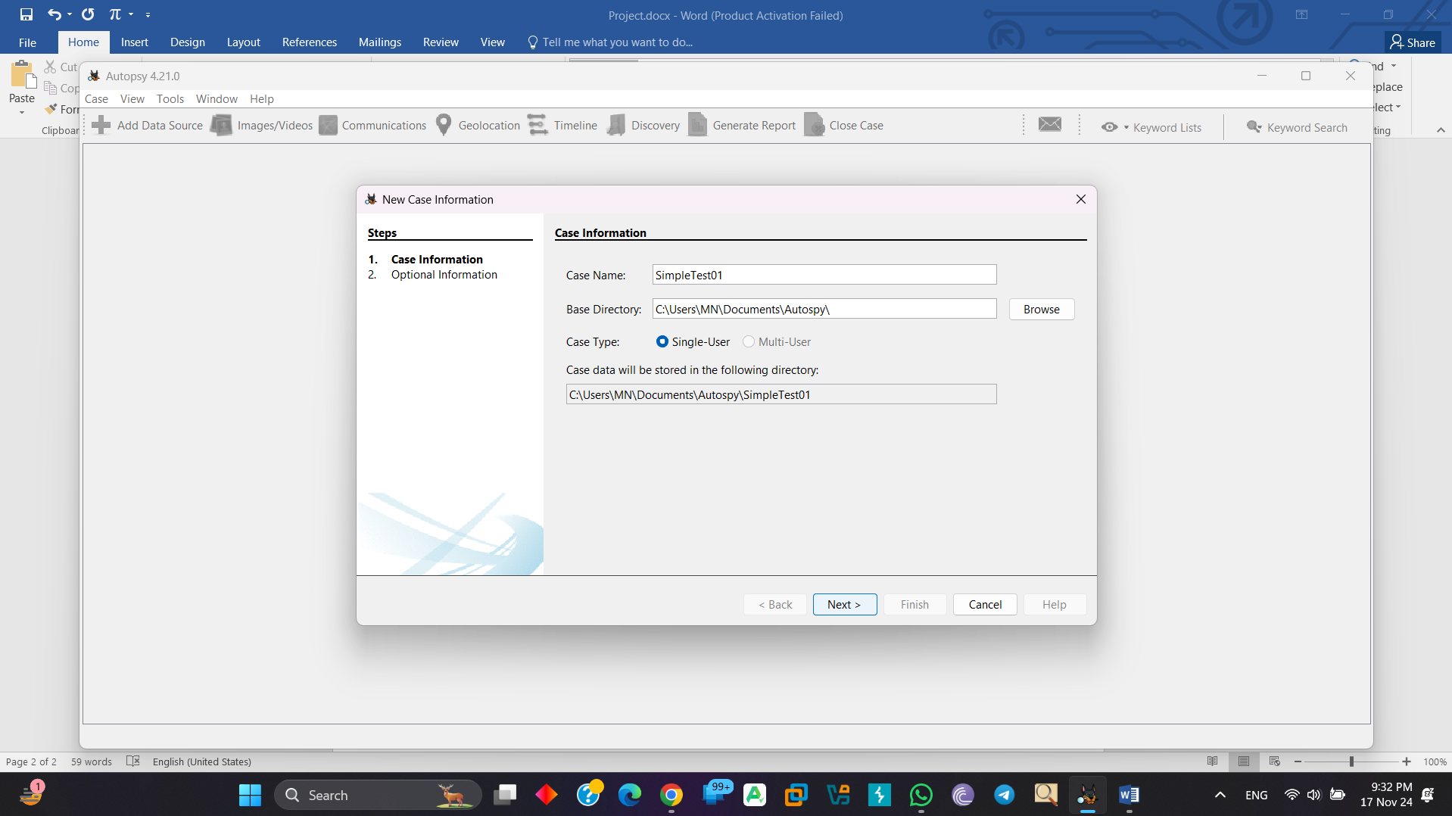

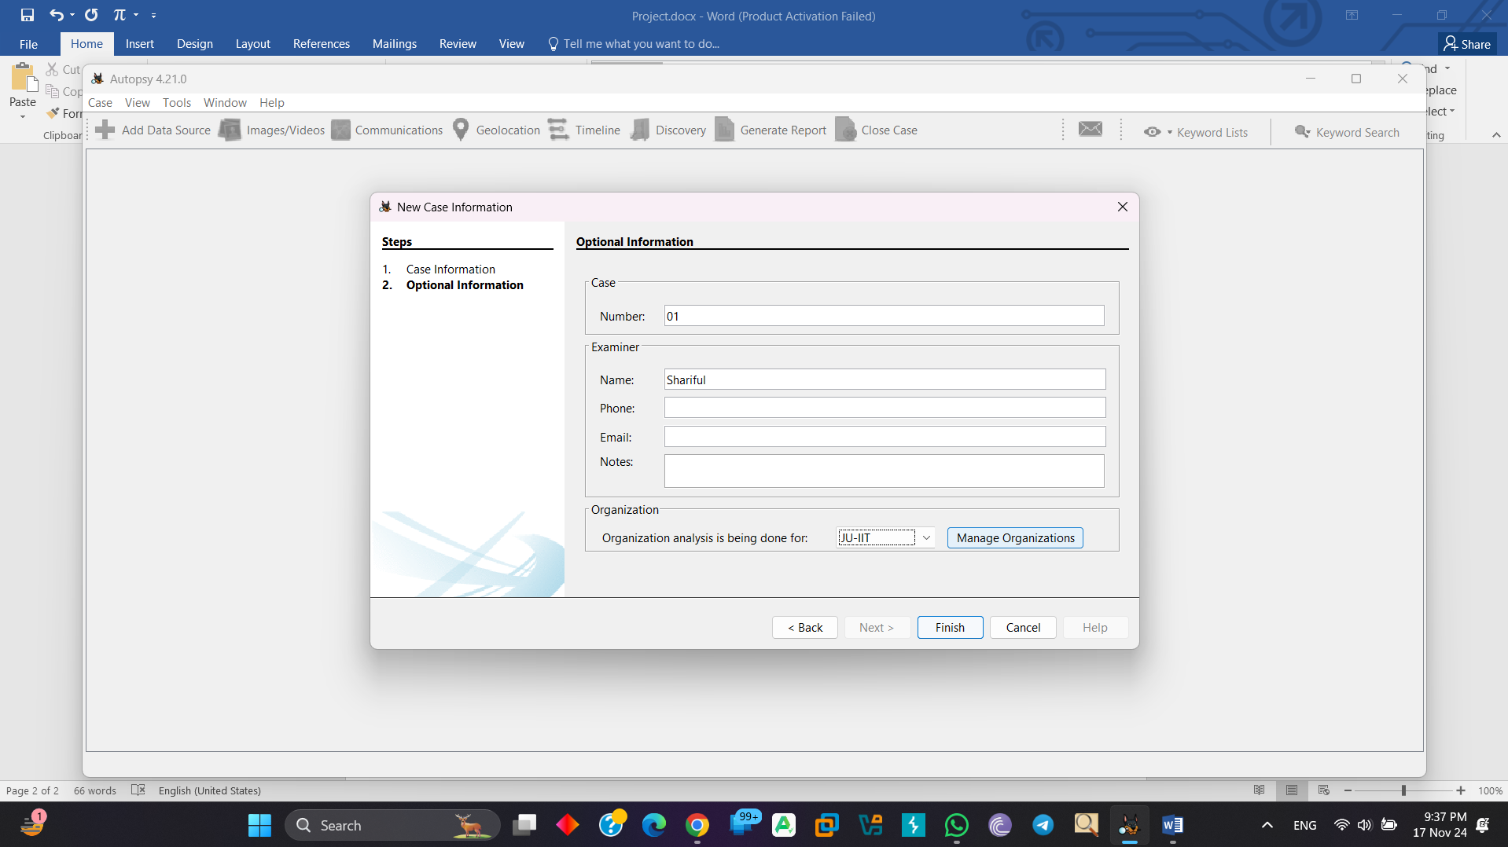

Select a Host (Ex: Generate New Host name based on data source name)

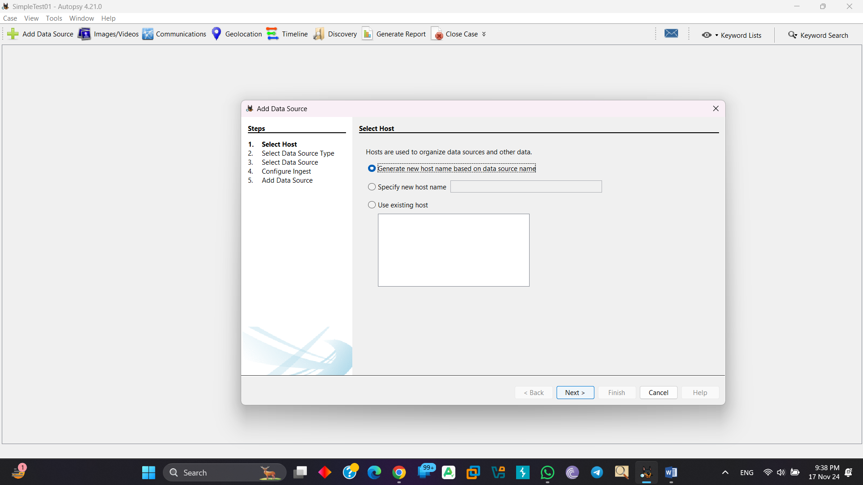

Select any one type of disk:

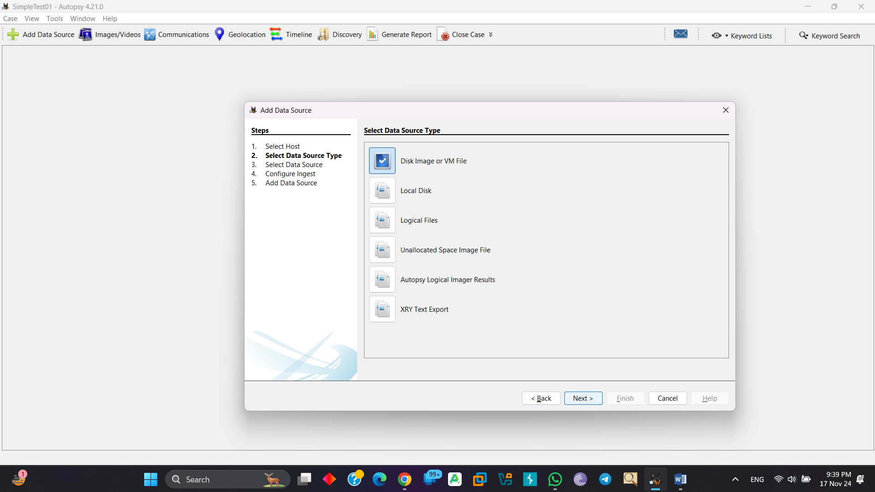

Browse the image:

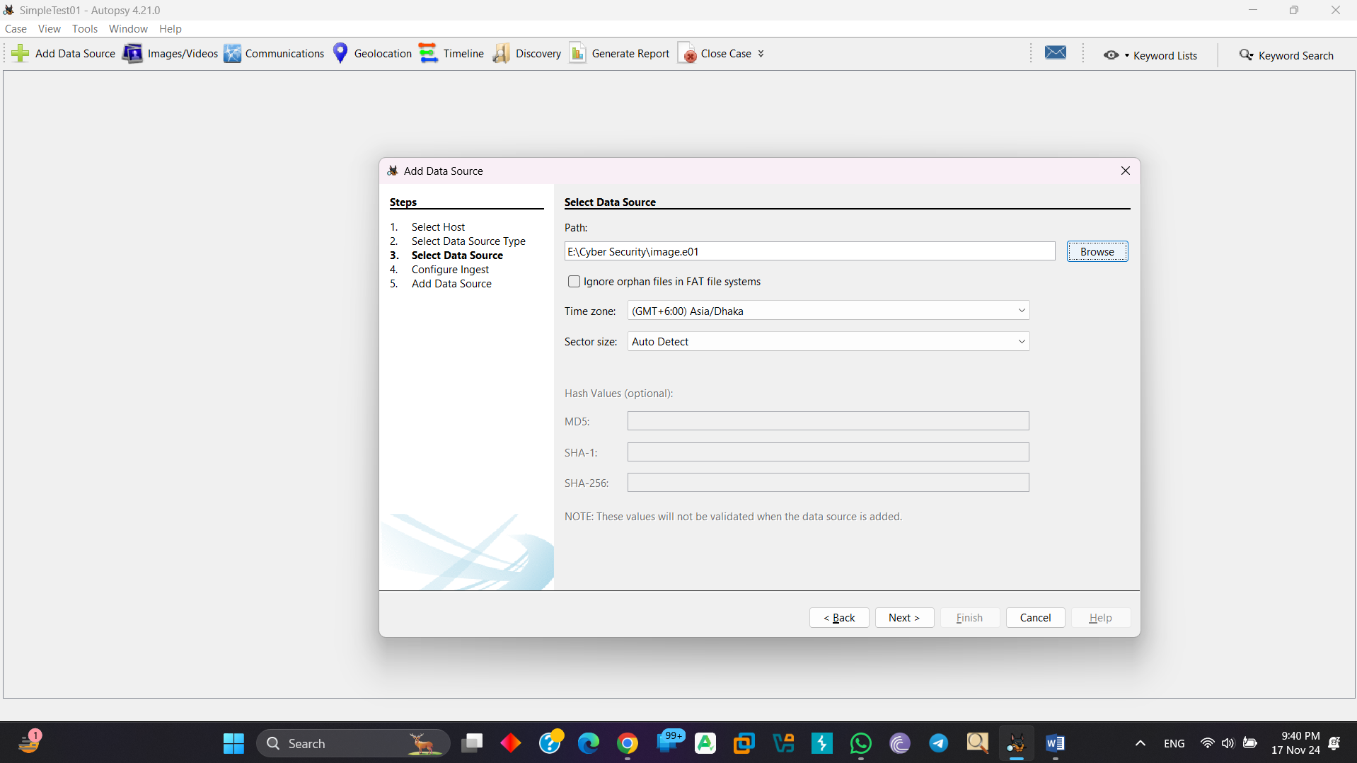

Select needed item and enter next:

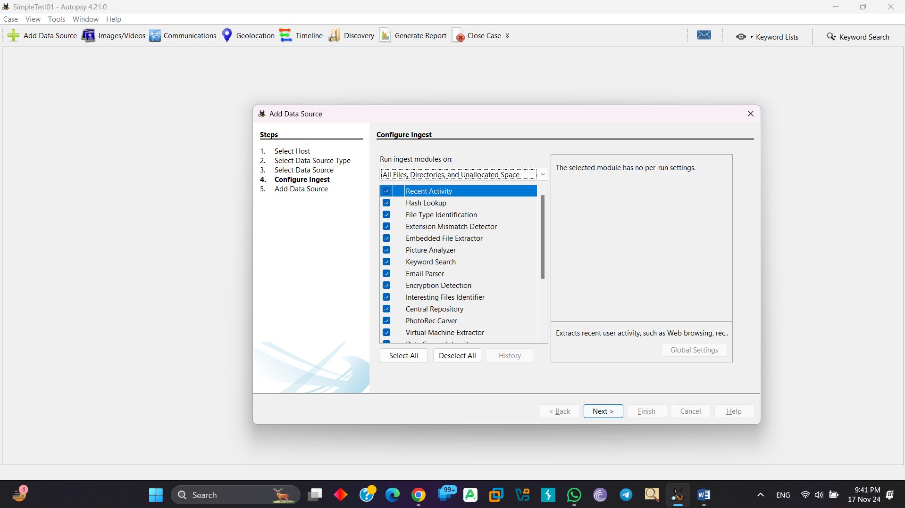

Here add data source:

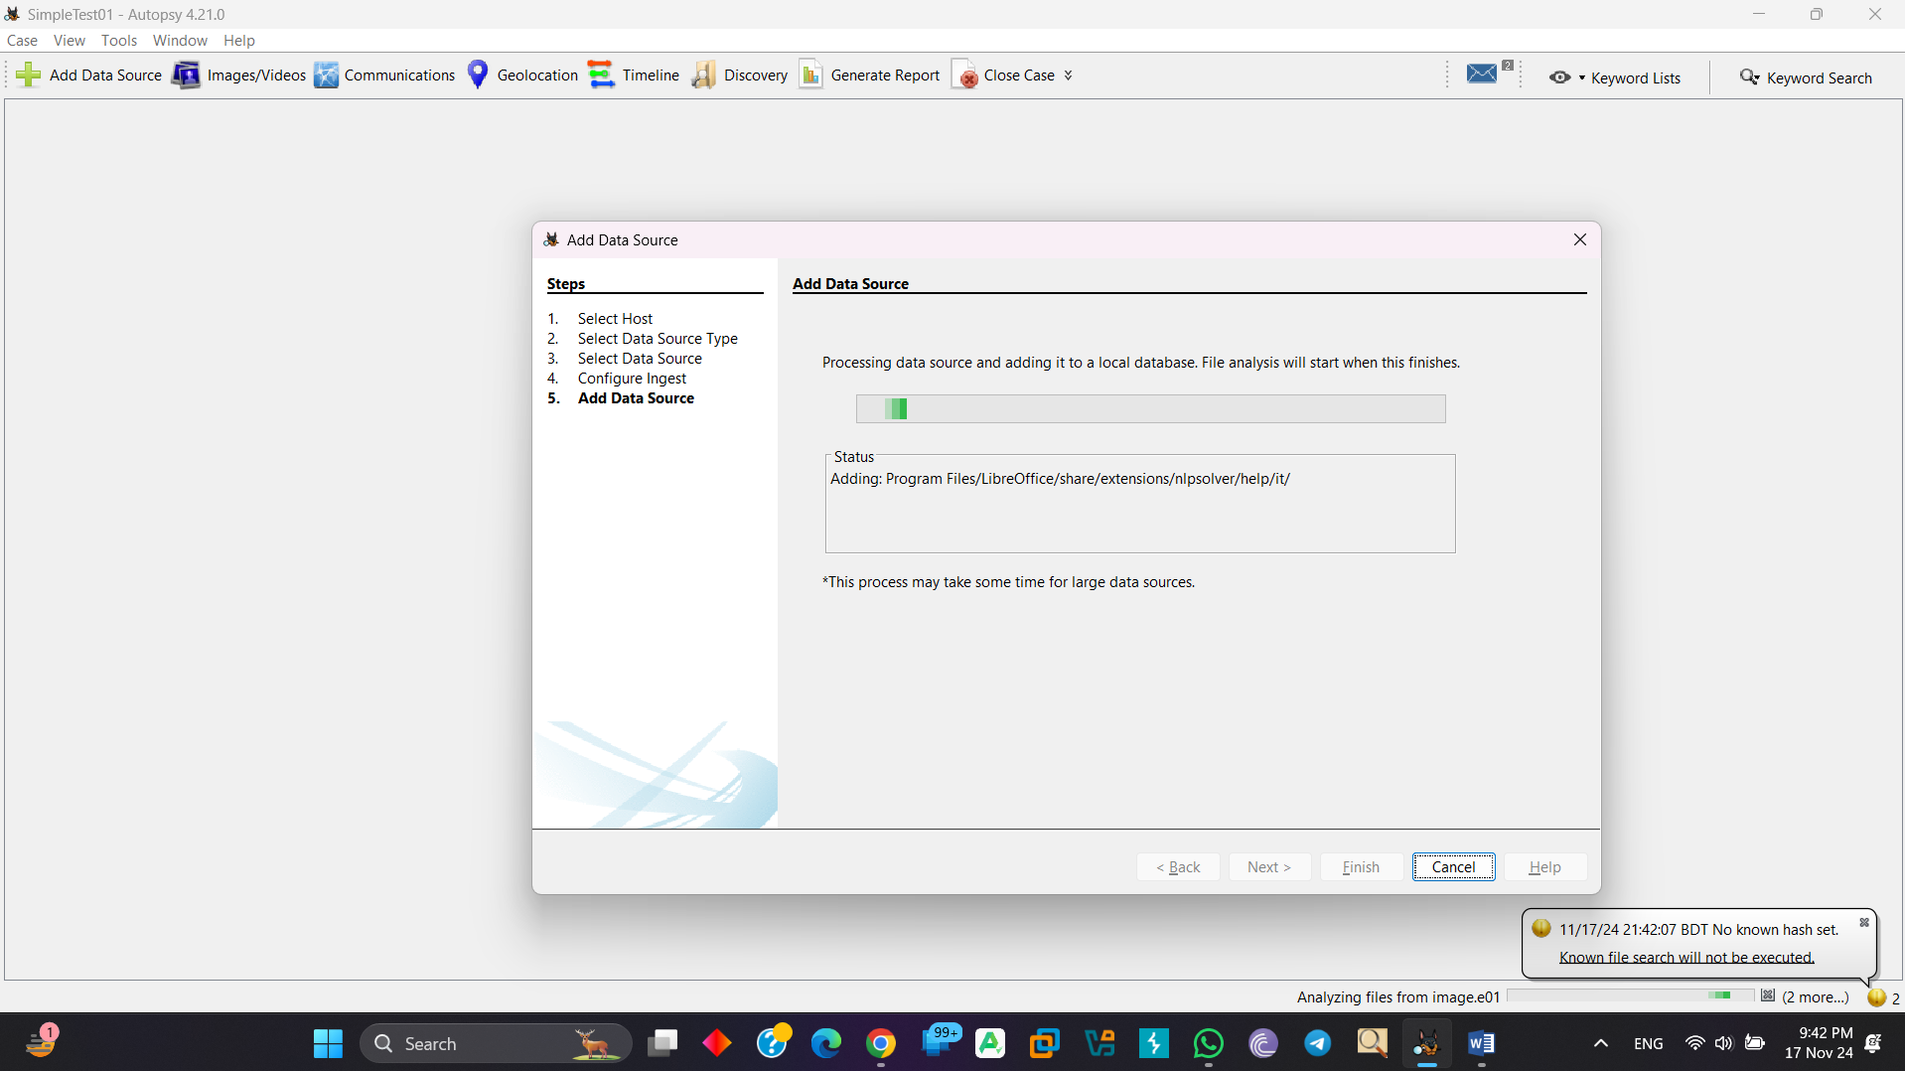

Here is 5090 Delete file:

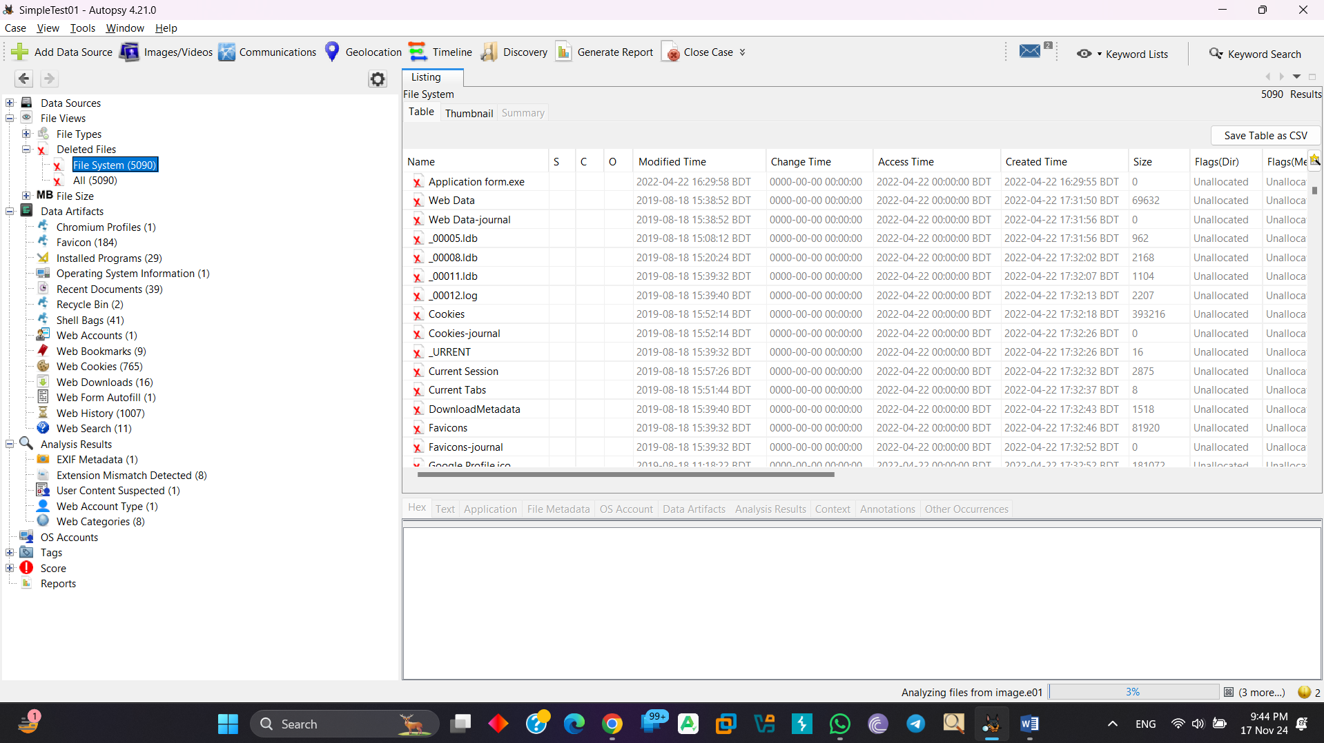

Here are two-email message:

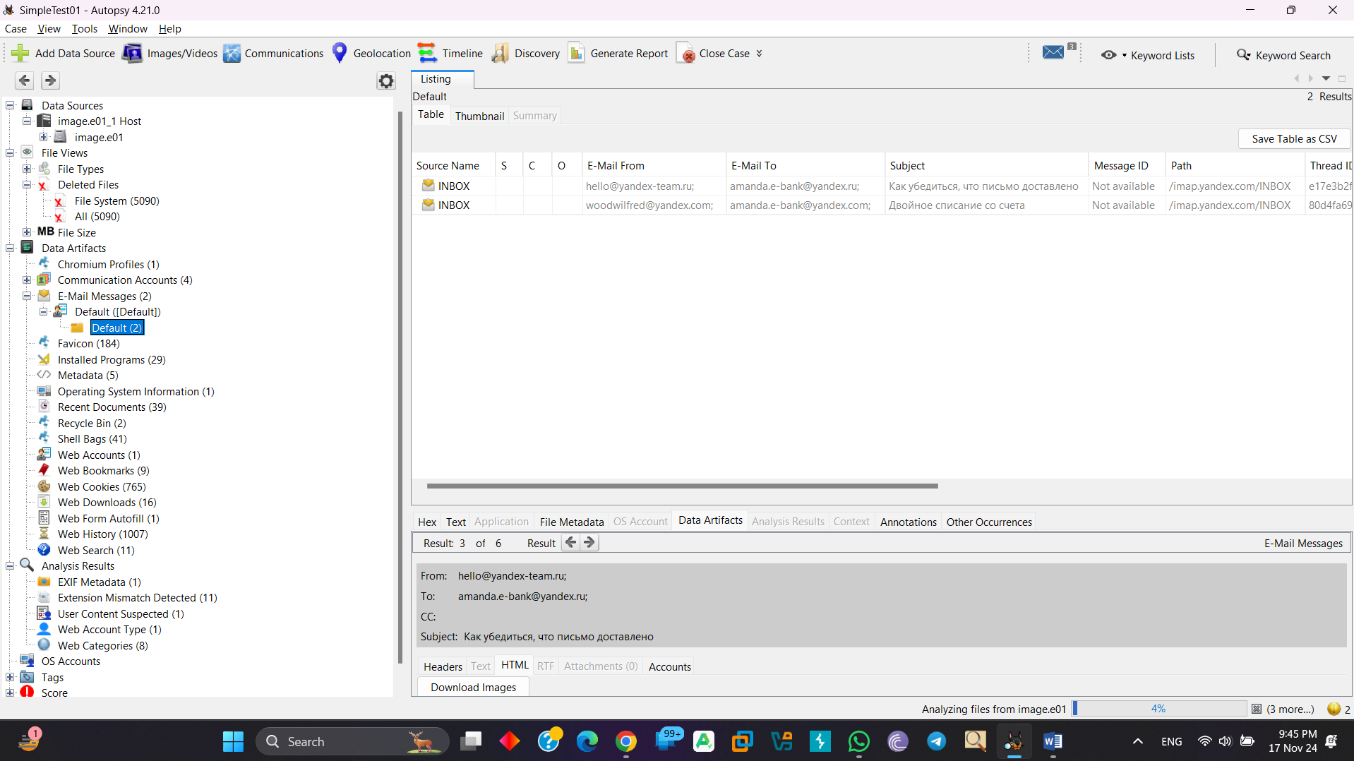

Here is show email from/email to and text of email:

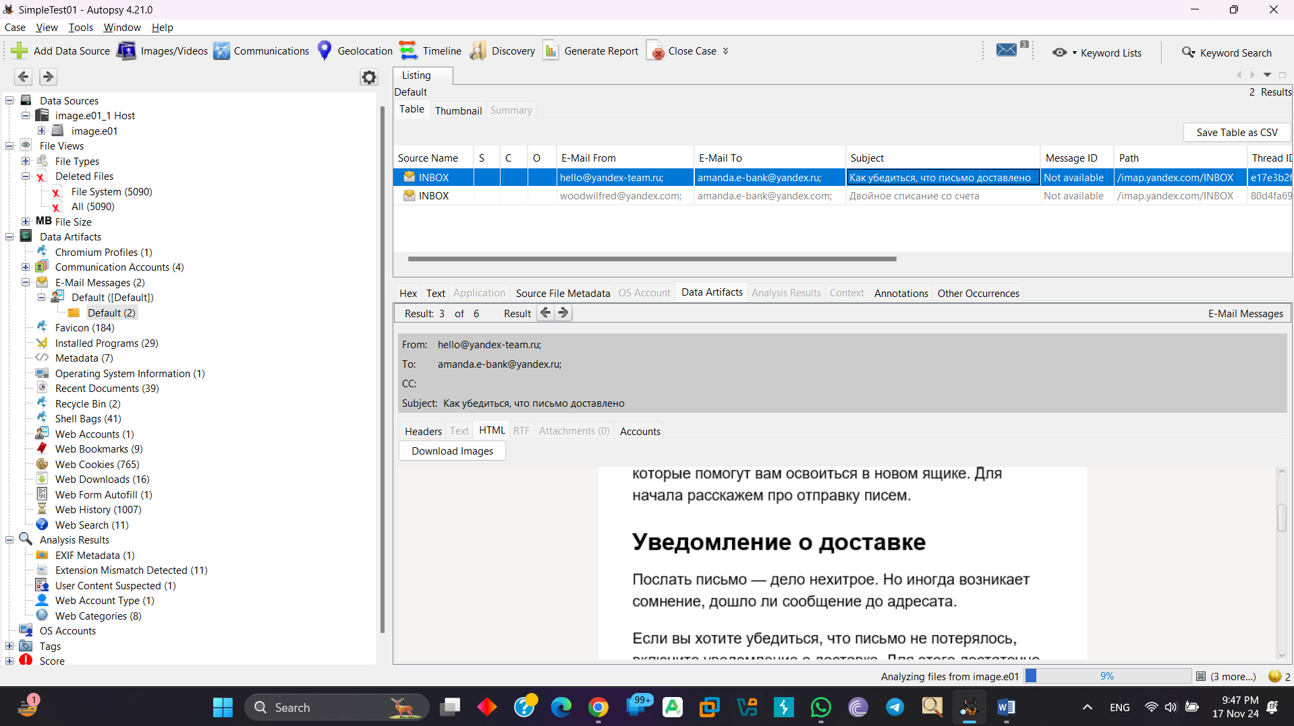

Here is an EXIF Metadata:

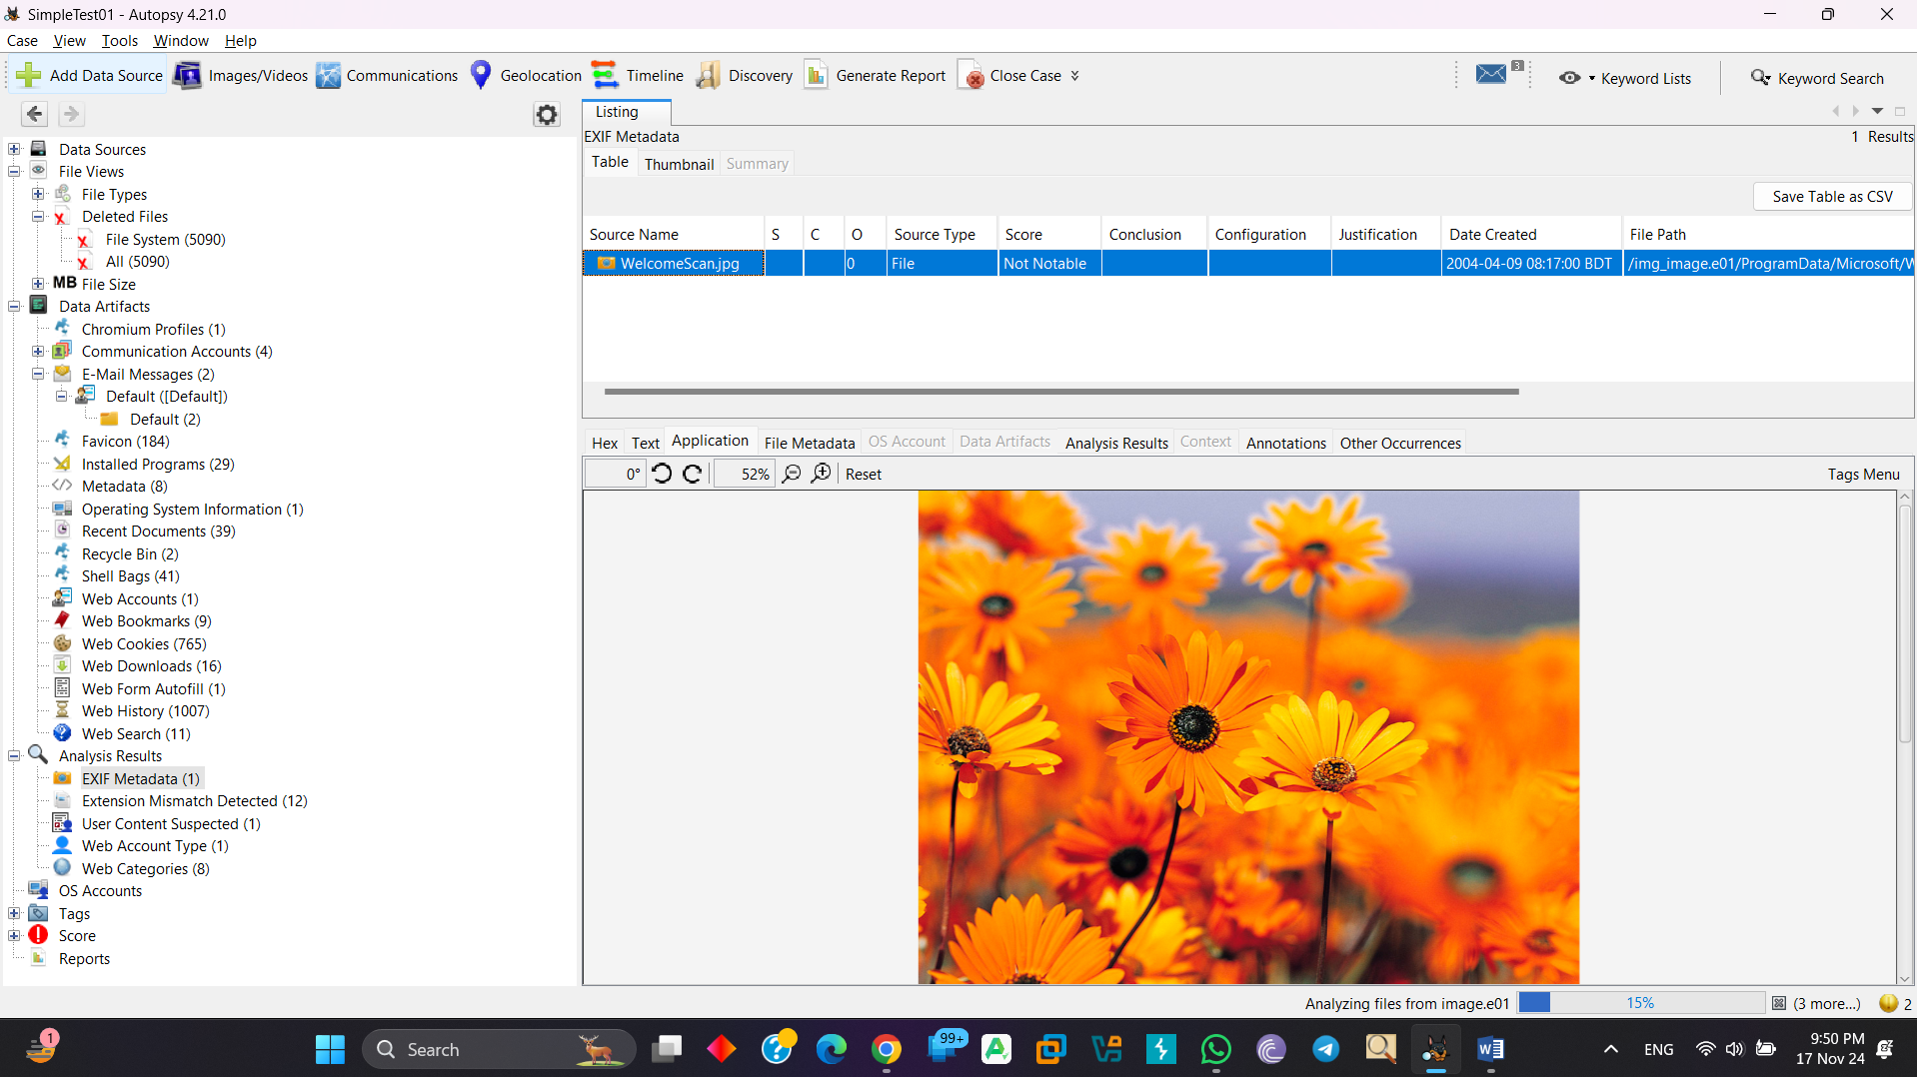

There are 12 suspicious item:

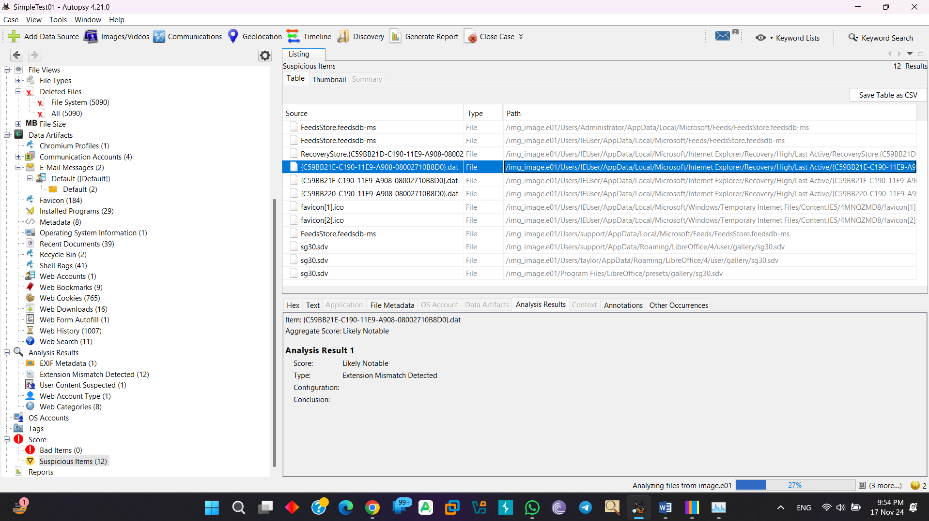

In addition, more other report item:

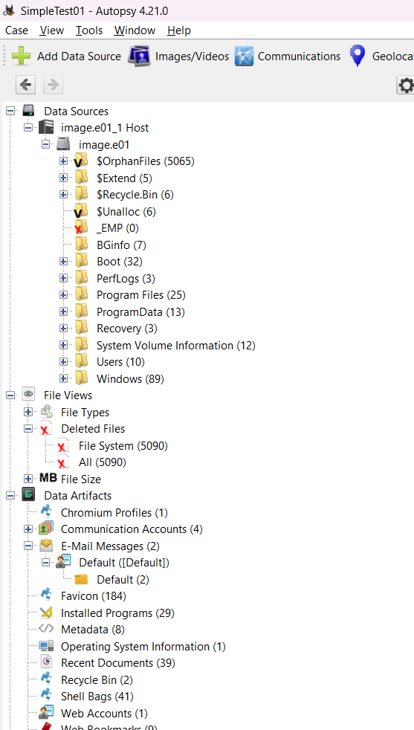

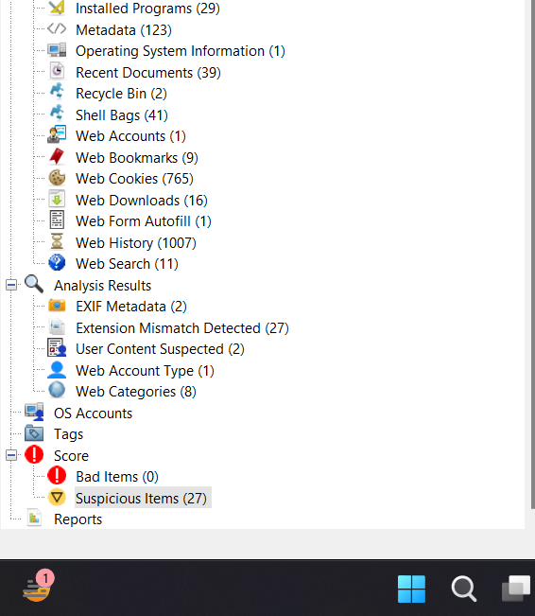

**Disk Forensics with FTK Imager**

In the beginning go to File🡪Create new disk:

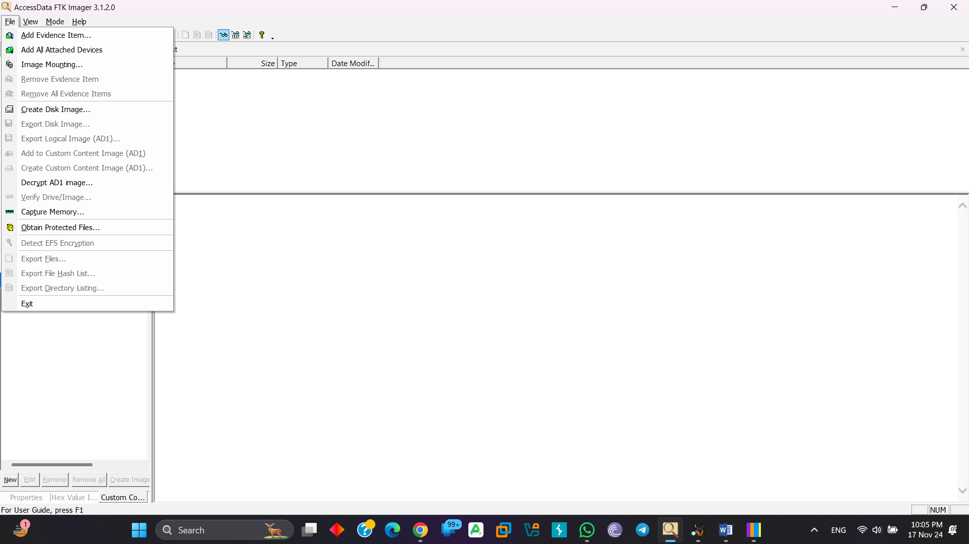

Select any one type:

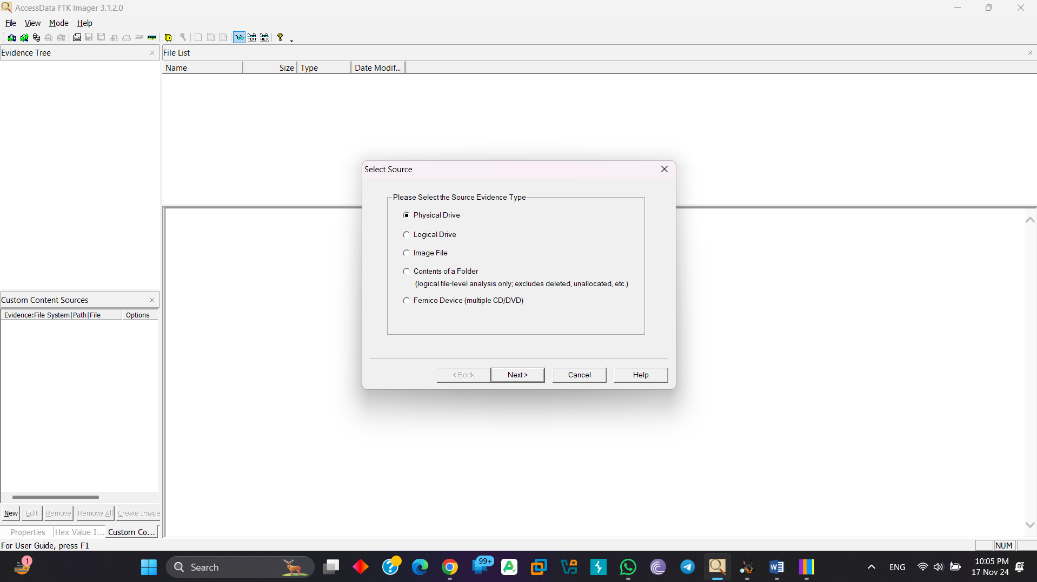

Select the drive:

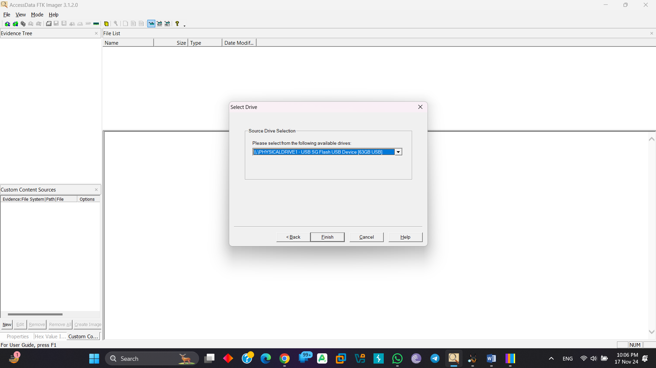

Add image type (any one from them):

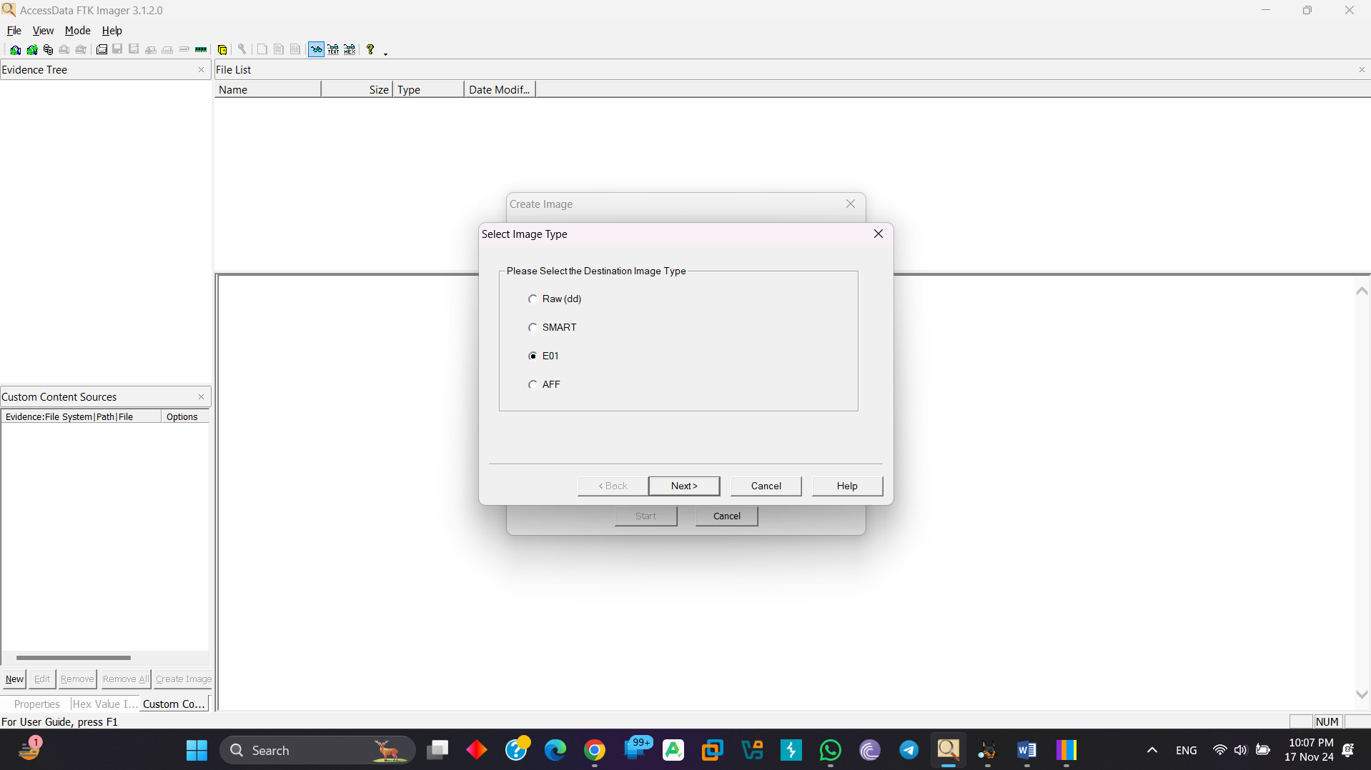

Set Evidence Item Information:

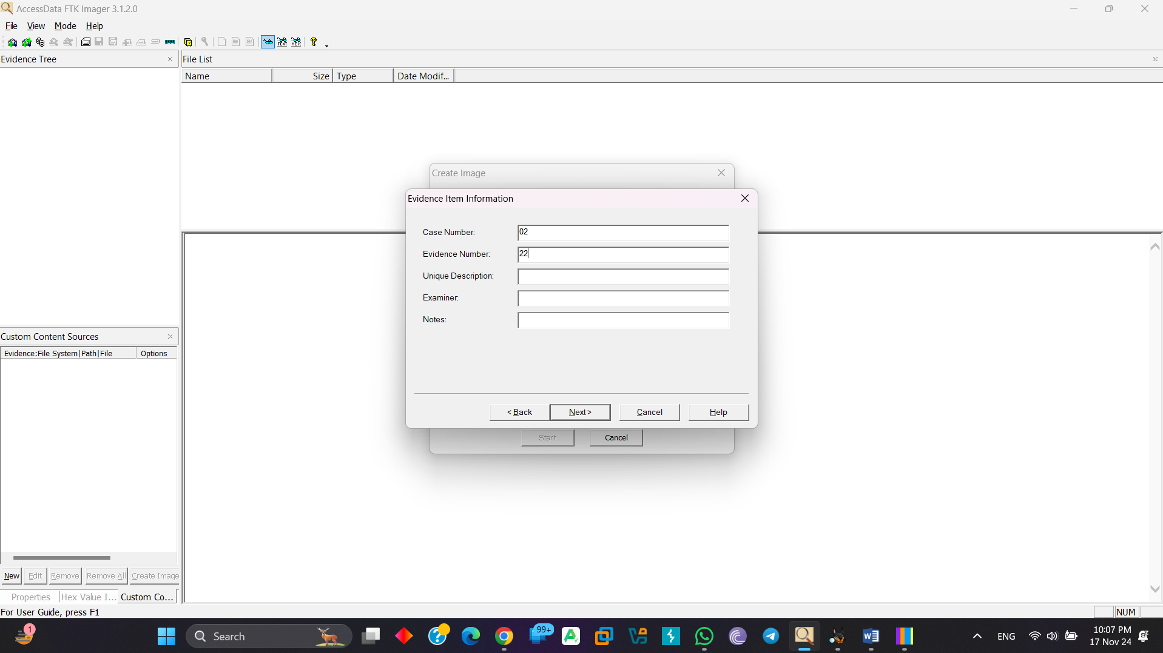

Select Destination folder and set file name and can resize Image Fragment size:

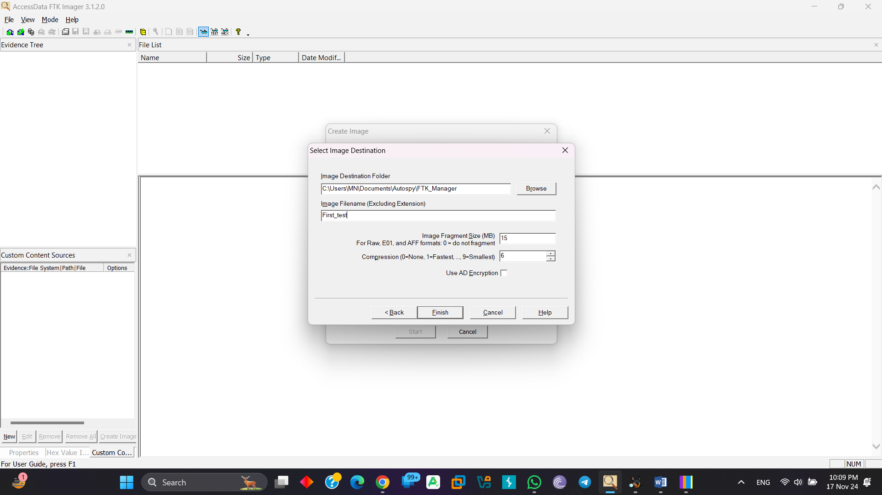

Its take huge number of time for Processing depends on processing disk size:

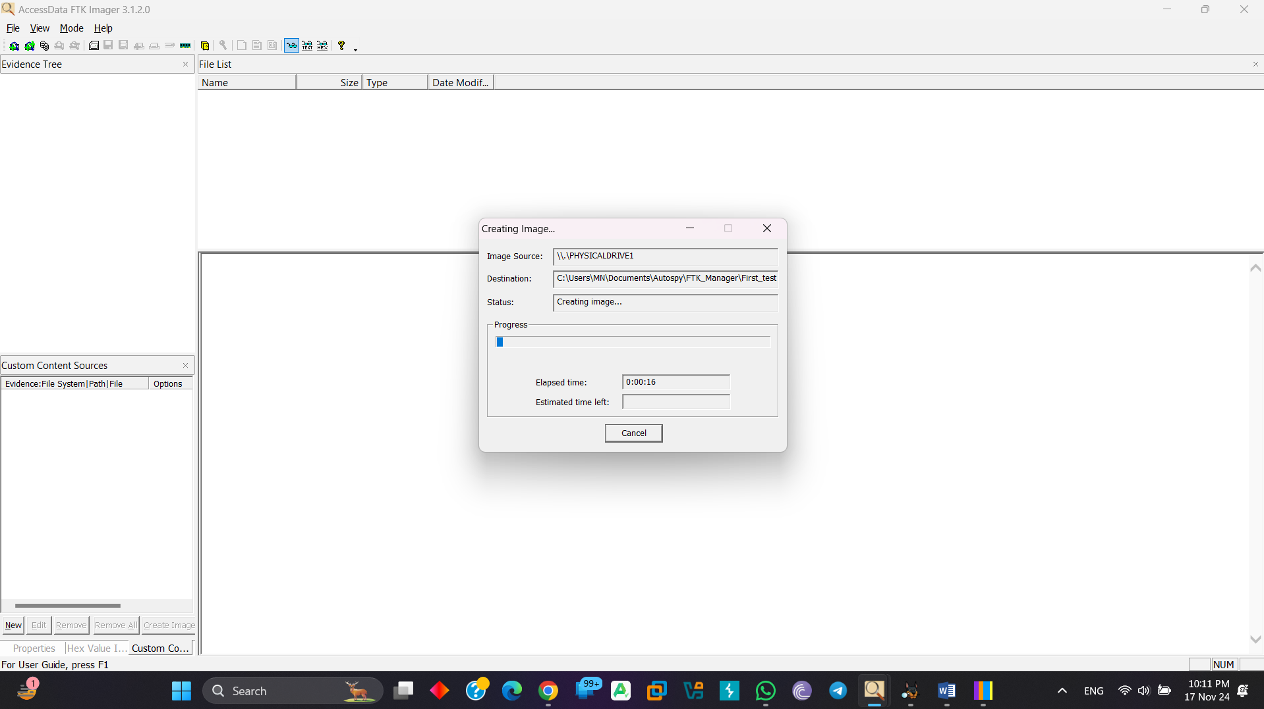

It’s take about 49 minutes to execute:

